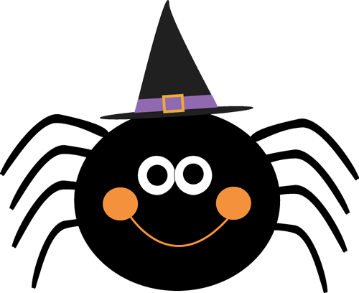

Mrs. Cost’s Weekly Newsletter

October 10th -October 13th

scost@saralandboe.org

π

**Skills Being Taught This Week**

**Reading:** Open Syllable (a, e, i, o, u), author’s purpose and shades of meaning verbs

**Math:** Addition and Subtraction within 10

**Language Arts:** Interrogative Sentences

**Science:** Physical & Developmental Stages of Animals

**Dates to Remember**

**Thursday, October 12th –**Seward Farms Field Trip

**Friday, October 13th** – Out of Uniform $2

**Week of October 16th** – Book Fair

**Tuesday, October 17th** – Report Cards go home

**Friday, October 20th** – Grandparents’ Day Program

8:30 Garner, Harrison, Little, West

9:45 Cost, Parker, Prater, Smith

11:30 Martin, Rhoads, Wallace

1:00 Campbell, Day, Reding

**Week of October 23rd** -Red Ribbon Week

**Tuesday, October 31st** – Halloween Costumes may be worn

**Wednesday, November 8th** – Yearbook & Class Pictures

**Classroom Reminder**

**Fun Friday Snack**

Thanks to Landry’s family for sending in snacks. This Friday, we have Maylee’s family scheduled to bring snacks.

**Fall Break**

We hope you all had a nice long weekend with your families. We began the 2nd quarter of first grade today. Please remind your child that we will be learning lots of first grade skills between now and Christmas break. It is very important to remain attentive and on task during the next nine weeks.

**Seward Farms Field Trip**

Our filed trip to Seward Farms is this Thursday, October 12th. Additional details and reminders about what to bring or send will be sent home on Tuesday or Wednesday.

**Grandparents’ Day**

First Grade has been preparing for a special day for Grandparents during their music classes. Please let our Grandparents know that they are invited to attend their special day at our school on Friday, October 20th. We will send more information soon. ☺

**Be A Champion! READ!**

Flyers were sent home a couple of weeks ago. Read the information, complete the back of the flyer, and return to the teacher by October 24th, if you would like for your child to qualify to win IRON BOWL tickets! ☺

**Red Ribbon Week Schedule**

Monday 10/23 – “Your future is bright” Wear sunglasses with uniforms.

Tuesday 10/24- “Sock it to Bullying!” Wear silly socks with uniform.

Wednesday 10/25 – “Team Up” Wear team jerseys with uniform bottoms.

Thursday 10/26 - “Use your Head: Make Good Choices!” Wear a hat with uniform.

Friday 10/27- Band Together: Unite the Land! Wear Spartan attire and receive a wristband.

**Halloween**

Students may wear non-scary and non-violent costumes on Tuesday, October 31st. Please make sure that costumes are comfortable to wear all day and that students can go to the restroom without help with costume.

Students should bring a bag or bucket to carry treats. Please remember to check to the Snack letter that will be sent next week and send your child’s item. ☺

**Week 9**