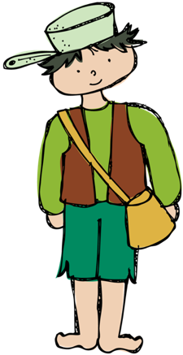

Mrs. Cost’s Weekly Newsletter

September 18th – September 22nd

scost@saralandboe.org



π

**Skills Being Taught This Week**

* Reading: -ing, -ung, -ong, -ang
* Compare & Contrast, Plurals & Possessives
* Math: Drawing Diagrams, Compare groups and subtract 4 & 5
* Language: Poetry, Review
* Social Sciences: Apples

**Classroom Reminders**

**Fun Friday:** A HUGE thanks to Journei’s family for sending in snack last week. This Friday, we have Maybrie’s family scheduled to send in snack.

**Homecoming Week Activities**

**Monday, 9/18**- Hero Day-Dress like a Superhero.

**Tuesday, 9/19**- Camo/Princess Day-Dress in camo or as a princess.

**Wednesday, 9/20**- Famous People Day-Dress as a famous person.

**Thursday, 9/21**- Color Day- First Grade is the color black. Dress head to toe in black.

**Friday, 9/22**- Spartan Spirit Day- Dress in Spartan Spirit wear.

**Water Bottles:** Please make sure that your child has ONLY water in his/her bottle.

**Accelerated Reader:** Thank you for helping your child to read at home. You are really supporting your child’s literacy skills! We have several students that have met their 1st quarter goal.

**Week 6**

**Spelling Words**

1. rang 6. king

2. bang 7. hung

3. sing 8. wing

4. song 9. fang

5. long 10. lung

**Red Words**

was

to

or

purple

brown

white

**Dates to Remember**

**Friday, September 15th** – Out of Uniform $2

**Thursday, September 21st** – Field Trip to High School

**Week of September 18-22** – Homecoming Week

**Week of September 25th** – Seward Farm Field Trip Money and Forms Collected

**Friday, October 6th** – End of 1st Quarter

**Monday, October 9th** – No School, Teacher Workday

**Wednesday, November 8th** – Yearbook & Class Pictures