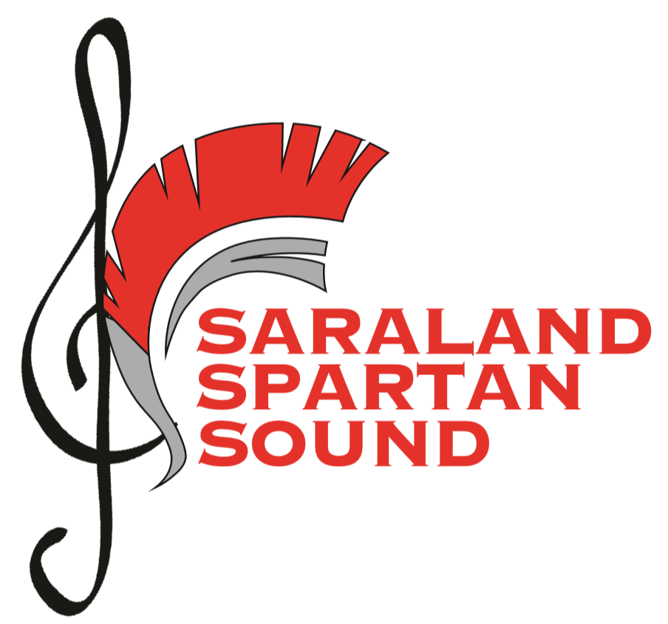

2021-2022

**Color Guard &**

**Auxiliary Information Packet**

Clinic Dates: April 26th-27th

Audition Date: April 29

Time: 3:15pm-5:00pm

Where: Practice Gym

NO Experience Required!

ALL are Welcome!

**Who** **can attend:** 8th - 11th graders in good academic standing with a positive behavior background and appropriate

physical ability that allows them to fully participate in the activity.

**What to wear**: -*clinic*: black dance clothes (leotard, leggings or tights, spandex shorts); jazz shoes; hair up, no jewelry

-*auditions:* same as clinic.

**What to bring: Medical Release Forms**

**$10 Clinic Fee (Make checks to SHS Band)**

*Color Guard is a performing ensemble that accompanies and visually represents the music of the marching band by incorporating flags, rifles, sabres, props, batons, and dance to enhance the half-time show. Being a performer in the color guard is a commitment that requires DEDICATION, MOTIVATION, and SELF-DISCIPLINE.*

Come join our family and be a part of something greater than yourself!

If you have any questions please see a current Color Guard member, Ms. Bryant, Mr.Davidson, or Mr. Ellis

**2021-2022 Spartan Sound Color Guard**

**Member Commitment**

I understand that as a member of the 2021-2022 Saraland Auxiliary I will be expected to uphold and adhere to the following

- **Attendance** to *all* scheduled *rehearsals* and *performances*; absences due to conflicts with other extra-curricular activities or jobs are unacceptable; absences may result in removal from performances or from the Saraland Auxiliary

- Fulfillment of *all* *financial obligations* in a timely manner including program fees, uniforms, designated fundraisers, and other expenses incurred during seasons: late or delinquent pay or failure to meet fundraising requirements may result in removal from the Saraland Auxiliary

- Maintenance of passing grades in all academic classes: repeated failing grades may result in removal from the Saraland Auxiliary

- Compliance with all auxiliary, band, and school rules and instructions

- Respectful representation of my school, family, community, and band at all times

- Efforts to maintain a constructive attitude

- Efforts to support the team as an individual and ensemble member

- Members are expected to put forth the time and effort needed to raise their standards when it comes to technique and performance ability. Every day is a day to improve and become a better performer.

*Failure to meet any of these commitments may result in temporary or permanent removal from performances or the program. No financial refunds will be given if students are removed from the program for failing to comply with these standards.*

**Financial Commitment**

The following is a schedule of membership fees payments for the Saraland Spartan Sound Band & Auxiliary. This is a payment plan that will assist in dividing fees into easy monthly payments. ***Members are responsible for all fees, in full, regardless of the date they join.* It is very important that the payment dates below are met on time!**

Fundraising

Fundraising will be ongoing throughout the marching and indoor seasons. Students are expected to participate in all fundraising and meet ***minimum fundraising amounts*** for each fundraiser. Those who do not participate will have to pay the minimum fundraising amount ***out of pocket in addition to the fees listed below***.

Fees

**Due Fee Amount Checks to:**

May 7th Uniform Payment #1 $75 SHS Band

May 7th Booster Installment $100 SHS Band

May 21st Uniform Payment #2 $75 SHS Band

July 15th Gloves, Shoes, Poms $75 ($15 + $35 + $25) SHS Band

August 12th  Jacket & Pants $75 SHS Band

Aug, Sep, Oct Remaining Booster Fee $75 (3 payments x $25) SHS Band

1st Quarter Class Fee $50 SHS Band

Spartan Sound Color Guard 2021-2022

**Fees**

|  |  |  |  |
| --- | --- | --- | --- |
| **Fee** | **Amount** | **Due Date** | **Additional Information** |
| Clinic Fee | $10 | April 26th |  |
| Uniform Payment 1*  Booster Installment | $75  $100 | May 7th  May 7th | Uniforms are made to fit each performer.  Booster Down Payment  Bag, Shirt, Shorts |
| Uniform Payment 2** | $75 | May 21st |
| Accessories | $75 | July 15th | Gloves, Poms, Shoes |
| Warm Ups | $75 | August 12th | Jacket, Pants |
| Remaining Booster Fee | $75 | 3 Payments x $25: August, September, October | Meals, Equipment, Transportation, Etc. |
| Class Fee | $50 | 1st Quarter | Equipment, Fees, Supplies |

*\*Majorettes’ uniform payments will be held until the feature twirler decision is made. Payments should be made on time and placed in a sealed envelope with the student’s full name, amount enclosed, and “Majorette Uniform Payment.”*

**Schedule**

|  |  |  |  |
| --- | --- | --- | --- |
| *Tentative***Marching Season Color Guard Schedule **Attendance to all scheduled events is** *mandatory***\*\*** | | | |
| July 14T, 15W | Choreography Camp | 8:00 – 5:00 pm  *See Additional Info 🡪 | Lunch will be from 12-1:30PM |
| July 19-23, 26 – 30 | Band Camp | Times Vary  *See Additional Info 🡪 | *Monday, Tuesday, Thursday, Friday: 1-9PM  Dinner Break 5-6PM  *Wednesday: 8-5PM  Lunch Break 12:00 – 1:30 |
| July 30F | Preview Performance | 7:00 | *See what we accomplished during camp!! Open to public!* |
| *August 5* | Rehearsal and Cookout | Times Vary  *See Additional Info 🡪 | Rehearsal from 2:30-6  Cookout from 6-8PM |
| *Every* Tuesday, Thursday | Rehearsal | 2:45 – 4:15 | MANDATORY rehearsals are held each week throughout football season. |
| Every Friday | Football Games | 3:00 🡪 | MANDATORY attendance and participation at every football game (home & away; entire game) |
| Saturdays in Late September & October | Marching Band Competitions | TBD | MANDATORY attendance and participation at 3-4 marching contests. Specific dates & times will be given asap. |
| TBD | Parades, Other Events | TBD | *Information will be given when available* |

*Attendance to all scheduled events and rehearsals is mandatory for all members of the auxiliary. Failure to attend or fully participate may result in removal from performances or the auxiliary program.*

Spartan Sound Marching Band 2021-2022

|  |  |  |  |  |  |  |
| --- | --- | --- | --- | --- | --- | --- |
| Sunday | Monday | Tuesday | Wednesday | Thursday | Friday | Saturday |
| 07/11 | 07/12 | 07/13 | 07/14  Leadership, Guard, & Percussion Camp  8-5PM  Lunch:12-1:30 | 07/15  Leadership, Guard, & Percussion Camp  8-5PM  Lunch:12-1:30 | 07/16  Leadership Camp  1-5PM | 07/17 |
| 07/18 | 07/19  Band Camp  1:00 – 9:00PM  Dinner 5:00 – 6PM | 07/20  Band Camp  1:00 – 9:00PM  Dinner 5:00 – 6PM | 07/21  Band Camp  8:00 – 5:00PM  Lunch 12:00 – 1PM | 07/22  Band Camp  1:00 – 9:00PM  Dinner 5:00 – 6PM | 07/23  Band Camp  1:00 – 9:00PM  Dinner 5:00 – 6PM | 07/24 |
| 07/25 | 07/26  Band Camp  Band Camp  1:00 – 9:00PM  Dinner 5:00 – 6PM | 07/27  Band Camp  Band Camp  1:00 – 9:00PM  Dinner 5:00 – 6PM | 07/28  Band Camp  8:00 – 5:00PM  Lunch 12:00 – 1PM | 07/29  Band Camp  1:00 – 9:00PM  Dinner 5:00 – 6PM | 07/30  Band Camp  1:00 – 9:00PM  Dinner 5:00 – 6PM  Parent Preview Performance 7:00 | 07/31 |
| 08/01 | 08/02  Teacher Work Day | 08/03  Teacher Work Day | 08/04  Teacher Work Day | 08/05  Rehearsal  2:30-6PM  Band Cookout  6-8PM | 08/06  Teacher Work Day | 08/07 |
| 08/08 | 08/09  Students 1st Day | 08/10  Rehearsal  2:45-4:15PM | 08/11 | 08/12  Rehearsal  2:45-4:15PM | 08/13 | 08/14 |

*Attendance to all scheduled events and rehearsals is mandatory for all members of the auxiliary. Failure to attend or fully participate may result in removal from performances or the auxiliary program.*

Fees

**Due Fee Amount Checks to:**

May 7th Uniform Payment #1 (Guard) $75 SHS Band

May 21th Booster Installment (ALL) $100 SHS Band

May 21st Uniform Payment #2 (Guard) $75 SHS Band

July 15th Gloves, Shoes, Poms (Guard) $75 ($15 + $35 + $25) SHS Band

July 19th Marching Band Shoes (Band) $35 SHS Band

July 19th Remaining Booster Fee (Band) $75 SHS Band

August 12th  Jacket & Pants (Guard) $75 SHS Band

August  Class Fee (All) $50 SHS Band

Aug, Sep, Oct Remaining Booster Fee (Guard) $75 (3 payments x $25) SHS Band

**Feature Twirler**

**Skills and Training Requirements:**

* Strong understanding of the dance and baton fundamentals and choreography practiced in clinic

* Confident and professional performance skills

* Basic Baton Knowledge: Each applicant must be able to identify the parts of the Baton as well as demonstrate basic commands.

* Parts of the Baton: Ball, Shaft, Tip

* Basic Commands: Attention, Parade Rest

***\*Each applicant must be able to demonstrate each basic twirl with no assistance needed.***

**One Baton Skills

*Body Wrap (sling over the head, wrap around the neck, pass around the back, wrap around the waist, wrap around the knees, wrap around the ankles)

*Front hand Spins (starting slow and speeding up)

*Thumb Flips (both right and left hand)

*Figure 8’s (both right and left hand)

*Vertical Finger Twirls (both right and left hand)

*One turn with flash

*One turn without flash

***\*Must be able to attempt a two turn that demonstrates advanced skill nearing mastery\****

**One Baton Horizontal Skills

*Horizontals (both right and left hand)

*Horizontal Finger Twirls (both right and left hand)

*Horizontal Toss (both right and left hand)

*Box Toss from right to left

**Two Baton Skills

*Horizontals

*Figure 8’s

*Horizontal in left hand with vertical finger twirls in right hand

*Horizontal in right hand with horizontal finger twirls in left hand

*High toss front hand spin

All interested in feature twirler or weapon line must audition for and make the Color Guard or Dance Team Sectionals and auditions for each line of the auxiliary will occur after the initial auxiliary audition on

**Thursday, May 6, 2021.**

*-This list is to serve as a guide, not a complete rubric or detailed list of all skills to be included in instruction and choreography during clinic and auditions.*

* All feature twirler candidates must audition for and make the flag line

* Advanced understanding and performance of baton skills

*Demonstration of a strong self-motivated, independent work ethic

*1:30-2:30 minute routine choreographed and performed by the candidate in front of judges.

*Please wear all black to the feature twirler auditions.

**\*\*\*Auditions will begin at 3PM pm on Thursday, May 6, 2021\*\*\***