Boating: Chapter 6 Review

(Unit 6: Responsibilities of a boat owner-Unit 6: Review)

1. As the operator of a vessel, you are responsible for ensuring that your passengers understand ________________________________ and __________________.
2. Before allowing anyone to operate a PWC, you should remind them that power is ______________________________________.
3. To protect the environment, you should practice the three “Rs” -- R______________,

R ________________, and R _______________

1. If you capsize in a canoe, kayak, or raft, you should stay on the ____________________ side of the craft.
2. What are three river hazards that peddlers should avoid?
   1. __________________________________
   2. __________________________________
   3. __________________________________
3. When picking up a skier, always keep them in the view and on the ___________________ side of the boat.
4. Identify the following water-skiing commands
   1. ______________________________________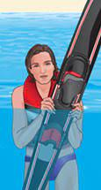
   2. ______________________________________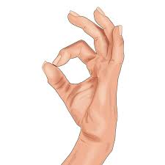
   3. ______________________________________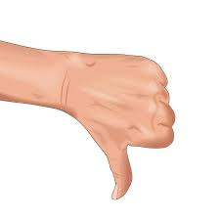
   4. ______________________________________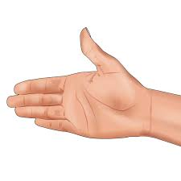
5. In addition to a displayed diver-down flag, what indicates that a diver may be below the water’s surface? ____________________________
6. When passing under powerlines and bridges, sailboat operators need to be aware of the _____________________ _____________________.
7. Hunters who use vessels to get to their hunting spots should always have their ________________.